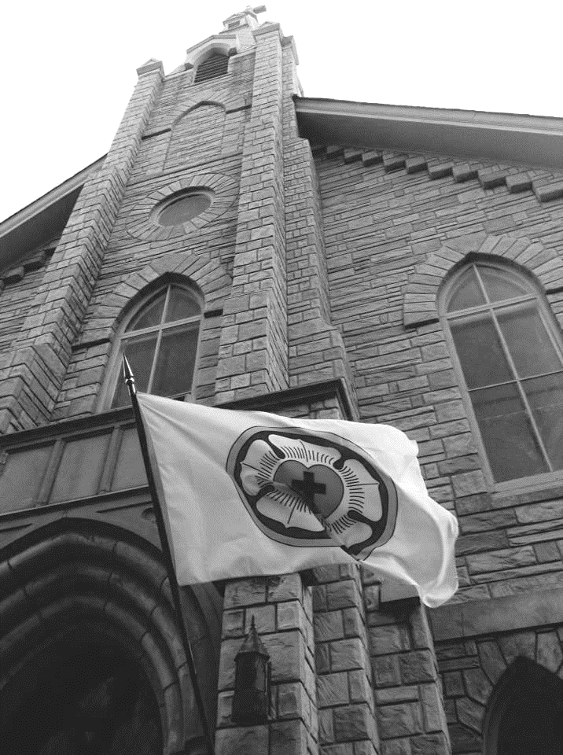

February 19, 2023

**~~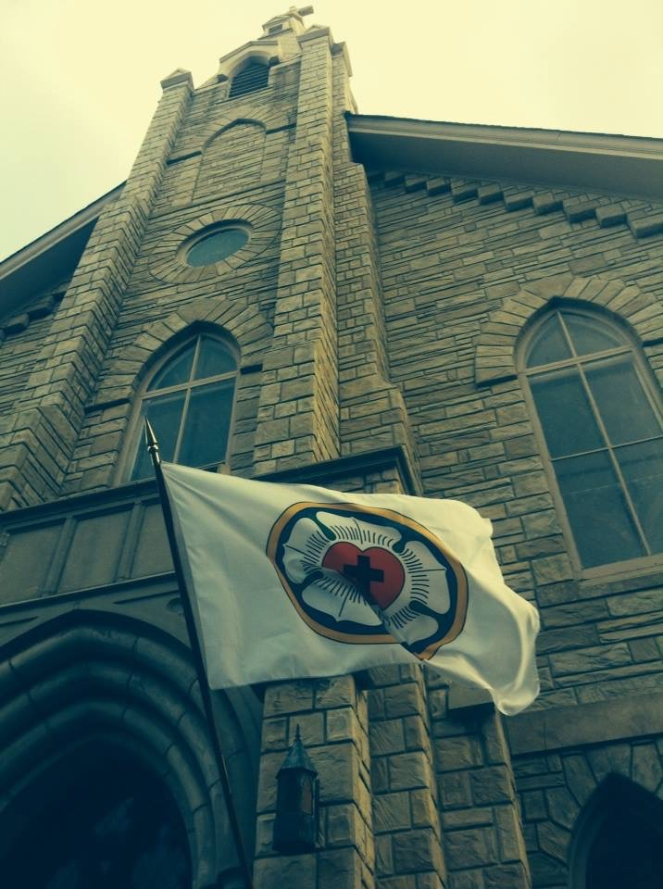~~The Transfiguration of Our Lord Trinity Lutheran Church**

**~~February 19, 2023 10:00 am**

*We’re glad you are here! You’ve come to a place where you can experience a real God with real grace for your real life, a place where you can connect with our Savior and His people! If you’re a guest with us today, we consider it a privilege to have you with us and hope you’ll come again. Please share your name with us by signing the Connect Card in the Trinity Today in your bulletin. Please include your address, phone number, and email. If you have any questions about the service or need assistance with anything, please don’t hesitate to ask one of our ushers for help!*

**DEAR PARENTS:** Out of all the responsibilities parents have in raising their children, leading them to know and connect with Jesus for life is the most important. We know it can sometimes be a challenge, but we commend and thank you for what you do when you bring your kids to church. Your family is a vital part of our community gathered in worship. If you need it, we have “busy” bags to help keep your young children occupied during the service. The bags are located near both entrances to the sanctuary. We also have a staffed nursery for children *ages 4 and under* if there is a need to take your child out of the sanctuary. It is located on the front left-hand side of the sanctuary.

**WIRELESS HEARING ASSIST HEADSETS** are available in the back of the sanctuary if you need assistance with hearing during worship. Feel free to ask an usher for one at any time.

**FREE PARKING:** Everyone is welcome to park on Sunday morning, free of charge, in the Best Park Parking Lot (directly across Washington Avenue from Trinity’s Campus).

**Our mission: Connecting people to Christ for life.**

**Our vision: experience : connect : reflect**

**www.TrinityMemphis.org**

**TrinityMemphis**

Pastor Michael Croom, Senior Pastor

pastorcroom@trinitymemphis.org

cell: (270) 348-2849

**Please be sure to keep your copy of Trinity Today!**

image2

**THE SACRAMENT OF THE ALTAR (HOLY COMMUNION)**

In Holy Communion (Lord’s Supper), we believe and joyfully confess that, as Jesus Himself says, He gives us His true body and blood to eat and drink with the bread and wine! We call this the “Real Presence.” Jesus gives this gift of Himself to us to forgive our sins, strengthen our faith and our union with Him, and strengthen our unity with one another as His Church (Matthew 26:26-28; Mark 14:22-24; Luke 22:19-20; 1 Corinthians 11:17-34; 1 Corinthians 10:16-17). Our Lord invites to His table baptized Christians who trust in Him alone for forgiveness and salvation, who trust His Words that He is present and offering forgiveness and grace in the Sacrament, who repent of all sin, who forgive others as He forgives us, and who are able to “examine” themselves (1 Corinthians 11:28) regarding these things.

As we share in Christ’s body and blood together, the Bible says we also confess the Gospel and our unity in it (1 Corinthians 11:26). Because of this, we practice “Close Communion.” This means that those who commune together do so with the intent of being united in the faith we confess and in our life together. We want everyone to partake of the Lord’s Supper. Because we desire everyone who communes at Trinity to do so in the unity that our Lord intends and to receive the fullness of the gifts He offers (1 Corinthians 11:27-30), we lovingly ask any who have not yet been instructed in the faith of Scripture, who have doubts about the church’s teachings, or who have united themselves in membership to a church that is not in fellowship with the Lutheran Church–Missouri Synod to first speak with the pastor about communing.

If you are a Christian but are not receiving Communion, we invite and welcome you to the Lord’s altar for a blessing. Please cross your arms to indicate you have come for a blessing.

We offer both individual and common cup. If you are unable to come to the front easily, please let the pastor or one of the ushers know. The pastor will bring the Sacrament to you at your seat. We encourage parents to bring your non-communing children for a blessing.

**For Good Health** – We ask everyone to please observe social distancing in accordance with your own comfort level as well as that of the people around you. Please take your worship bulletins with you when you leave. Wash hands and/or use hand sanitizer regularly.

The Transfiguration of Our Lord

**As We Gather**

In one sense, the Transfiguration of Our Lord provides a sort of climax to the first part of the story of Jesus in the liturgical year. In the glorious vision, Moses and Elijah appear as if to prove that everything written in the Bible in the Law and the Prophets has come true in the advent and appearance of Jesus, “true God, begotten of the Father from eternity, and also true man, born of the virgin Mary” (explanation of the Second Article). Yet this climactic event is not yet the true and complete climax of the story, but a transition now into the season of Lent and the road to the true climax: the cross of Good Friday, the resurrection of Easter, His ascension into heaven, and the sending of the Holy Spirit on Pentecost. There is so much more to tell. This brief glimpse of glory and Peter’s eyewitness account is to give us the strength and encouragement now to bring the story to completion in us, that we become witnesses in possession of the glorious hope of eternal life through the forgiveness of our sins.

Welcome and Announcements

Please note that during portions of the service where there are responsive speaking parts, P=Pastor, A=Assistant, and **C=Congregation.**

LSB = Lutheran Service Book (burgundy hymnal)

Prelude

Please stand

Opening Hymn *‘Tis Good, Lord, to Be Here LSB 414*

**Invocation** Matthew 28:19b; [18:20]

Invocation comes from the Latin “to call upon.” The words “In the name of the Father, Son, and Holy Spirit” are spoken at the beginning of the service and remind us of our baptism.

The sign of the cross may be made by all in remembrance of their baptism.

P In the name of the Father and of the T Son and of the Holy Spirit.

C Amen.

**Opening Sentences** *Psalm 117:1–2a; 96:8*

P Praise the Lord, all nations!

C **Extol Him, all peoples!**

P For great is His steadfast love toward us,

C **and the faithfulness of the Lord endures forever.**

P Ascribe to the Lord the glory due His name;

C **bring an offering, and come into His courts!**

**Confession and Absolution** *2 Peter 1:19*

P That we may enter into the holy presence of Christ, let us confess our sins that we may be made the righteousness of God.

C **We confess to You, almighty God, our blindness to Your glory and our reluctance to seek Your grace. We have sinned against You and our neighbors by our own fault in both our thoughtless actions as well as the good we have failed to do. For the sake of Your Son, our Savior Jesus Christ, forgive us. Renew our hearts, enliven us in spirit, and let us see Your glorious mercy.**

P “We have something more sure, the prophetic word, to which you will do well to pay attention as to a lamp shining in a dark place, until the day dawns and the morning star rises in your hearts.” In the stead and by the command of my Lord Jesus Christ, I forgive you all your sins in the name of the Father and of the T Son and of the Holy Spirit.

C **Amen.**

T Service of the Word T

**Hymn of Praise ~ This Is the Feast** *Revelation 5:12–13; 19:5–9*

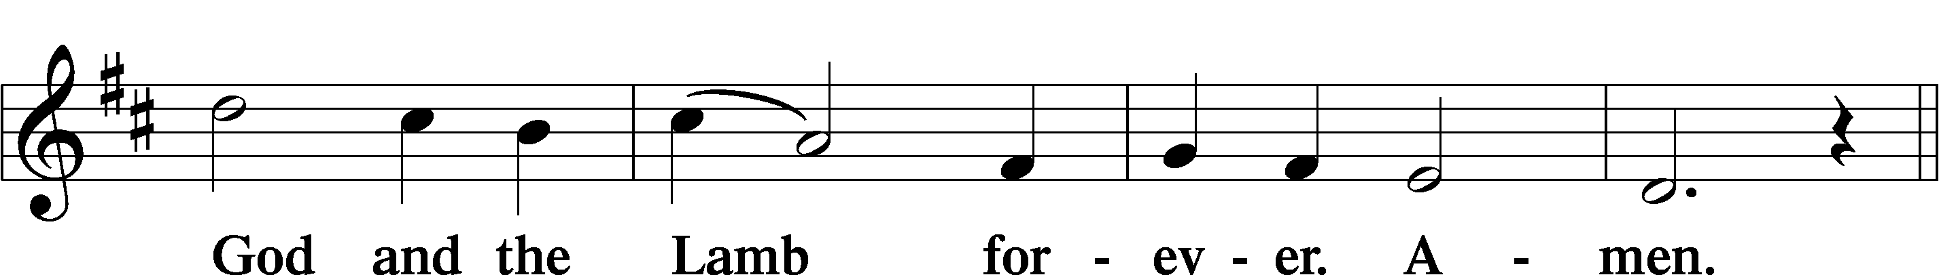

Salutation and Collect of the Day

The Collect is a brief prayer that is connected to a theme in the Scripture readings for the day.

P The Lord be with you. *2 Timothy 4:22*

C And with your spirit.

P Let us pray.

O God, in the glorious transfiguration of Your beloved Son You confirmed the mysteries of the faith by the testimony of Moses and Elijah. In the voice that came from the bright cloud You wonderfully foreshowed our adoption by grace. Mercifully make us co-heirs with the King in His glory and bring us to the fullness of our inheritance in heaven; through the same Jesus Christ, our Lord, who lives and reigns with You and the Holy Spirit, one God, now and forever.

C **Amen.**

Please be seated

Old Testament Reading Exodus 24:8-18

*8And Moses took the blood and threw it on the people and said, “Behold the blood of the covenant that the Lord has made with you in accordance with all these words.”*

*9Then Moses and Aaron, Nadab, and Abihu, and seventy of the elders of Israel went up, 10and they saw the God of Israel. There was under his feet as it were a pavement of sapphire stone, like the very heaven for clearness. 11And he did not lay his hand on the chief men of the people of Israel; they beheld God, and ate and drank.*

*12The Lord said to Moses, “Come up to me on the mountain and wait there, that I may give you the tablets of stone, with the law and the commandment, which I have written for their instruction.” 13So Moses rose with his assistant Joshua, and Moses went up into the mountain of God. 14And he said to the elders, “Wait here for us until we return to you. And behold, Aaron and Hur are with you. Whoever has a dispute, let him go to them.”*

*15Then Moses went up on the mountain, and the cloud covered the mountain. 16The glory of the Lord dwelt on Mount Sinai, and the cloud covered it six days. And on the seventh day he called to Moses out of the midst of the cloud. 17Now the appearance of the glory of the Lord was like a devouring fire on the top of the mountain in the sight of the people of Israel. 18Moses entered the cloud and went up on the mountain. And Moses was on the mountain forty days and forty nights.*

L This is the Word of the Lord.

C Thanks be to God.

Epistle 2 Peter 1:16-21

*16For we did not follow cleverly devised myths when we made known to you the power and coming of our Lord Jesus Christ, but we were eyewitnesses of his majesty. 17For when he received honor and glory from God the Father, and the voice was borne to him by the Majestic Glory, “This is my beloved Son, with whom I am well pleased,” 18we ourselves heard this very voice borne from heaven, for we were with him on the holy mountain. 19And we have something more sure, the prophetic word, to which you will do well to pay attention as to a lamp shining in a dark place, until the day dawns and the morning star rises in your hearts, 20knowing this first of all, that no prophecy of Scripture comes from someone’s own interpretation. 21For no prophecy was ever produced by the will of man, but men spoke from God as they were carried along by the Holy Spirit.*

L This is the Word of the Lord.

C Thanks be to God.

Please stand

**Alleluia and Verse** *John 6:68*

*The Verse is a portion, or portions, of scripture sung or spoken before the Holy Gospel, usually with “Alleluias” at the beginning and end.*

Holy Gospel Matthew 17:1-9

P The Holy Gospel according to St. Matthew, the seventeenth chapter.

C Glory be to You, O Lord.

*1After six days Jesus took with him Peter and James, and John his brother, and led them up a high mountain by themselves. 2And he was transfigured before them, and his face shone like the sun, and his clothes became white as light. 3And behold, there appeared to them Moses and Elijah, talking with him. 4And Peter said to Jesus, “Lord, it is good that we are here. If you wish, I will make three tents here, one for you and one for Moses and one for Elijah.” 5He was still speaking when, behold, a bright cloud overshadowed them, and a voice from the cloud said, “This is my beloved Son, with whom I am well pleased; listen to him.” 6When the disciples heard this, they fell on their faces and were terrified. 7But Jesus came and touched them, saying, “Rise, and have no fear.” 8And when they lifted up their eyes, they saw no one but Jesus only.*

*9And as they were coming down the mountain, Jesus commanded them, “Tell no one the vision, until the Son of Man is raised from the dead.”*

P This is the Gospel of the Lord.

C Praise to You, O Christ.

Please be seated

Children’s Message

Hymn *O Wondrous Type! O Vision Fair LSB 413*

Sermon Rev. Michael Croom

Please stand

Nicene Creed

This is one of the Christian Church’s ancient statements of faith, dating all the way back to the 4th Century A.D. The faith we confess in the Creed connects us to one another and Christians past and present.

C **I believe in one God,**

**the Father Almighty,**

**maker of heaven and earth**

**and of all things visible and invisible.**

**And in one Lord Jesus Christ,**

**the only-begotten Son of God,**

**begotten of His Father before all worlds,**

**God of God, Light of Light,**

**very God of very God,**

**begotten, not made,**

**being of one substance with the Father,**

**by whom all things were made;**

**who for us men and for our salvation came down from heaven**

**and was incarnate by the Holy Spirit of the virgin Mary**

**and was made man;**

**and was crucified also for us under Pontius Pilate.**

**He suffered and was buried.**

**And the third day He rose again according to the Scriptures**

**and ascended into heaven**

**and sits at the right hand of the Father.**

**And He will come again with glory to judge both the living and the dead,**

**whose kingdom will have no end.**

**And I believe in the Holy Spirit,**

**the Lord and giver of life,**

**proceeds from the Father and the Son,**

**who with the Father and the Son together is worshiped and glorified,**

**who spoke by the prophets.**

**And I believe in one holy Christian and apostolic Church,**

**I acknowledge one Baptism for the remission of sins,**

**and I look for the resurrection of the dead**

**and the life** T**of the world to come. Amen.**

Prayer of the Church *[1 Timothy 2:1-4]*

P Heavenly Father, You revealed Your glory in the transfiguration of Your Son, who tabernacled among us in the flesh. Open our eyes, that by faith we would see Him continuing to tabernacle among us in the Divine Service. Grant that we would heed Your admonition to “listen to Him” as He forgives and preserves us at the font, pulpit, and altar. Lord, in Your mercy,

C hear our prayer.

P Holy God, we ask for Your blessing on this congregation. As Moses was changed when he saw Your glory on Mount Sinai, may we who have beheld Your glory in the face of Christ also be transformed and given boldness of spirit to share Your glory abroad. Lord, in Your mercy,

C hear our prayer.

P Almighty God, Moses and Elijah appeared with the Savior in glory, witnessing all that the Law and the prophets speak about Him. Grant wisdom to all pastors and church workers to open Your Scriptures in such a way that everyone would hear the voice of Jesus calling them to life. Lord, in Your mercy,

C hear our prayer.

P Heavenly Father, bless the families of Your Church, that parents would teach the faith to their children and that the forgiveness of sins would be proclaimed in all households. Remember also all expectant mothers, that they and their babies would be kept safe and healthy throughout their pregnancies. Lord, in Your mercy,

C hear our prayer.

P Almighty Father, You alone establish all authority on earth. Bless those entrusted with authority both here and abroad to serve with integrity and honor for the well-being of all. Grant that all division, conflict and strife would give way to unity, peace and quietness. Lord, in Your mercy,

C hear our prayer.

P God of all comfort, You alone bring the peace that passes understanding to troubled hearts. Remember the afflicted, *[especially…]* that they would know Your presence, taste Your peace and receive healing according to Your gracious will, ever trusting in the hope of the resurrection. Lord, in Your mercy,

C hear our prayer.

P Lord God, Your power is beyond compare and Your glory beyond understanding. Open our hearts to know You through the glory of Your Son, whose saving will and purpose has rescued us from sin and death and made us Your own people by Baptism and faith; for to You, blessed and eternal Father, belong all honor and glory, worship and praise, with Your beloved Son and the Holy Spirit, one God, now and forever.

C Amen.

**Sharing of the Peace** *Matthew 5:22-24; Ephesians 4:1-3*

P Peace be with you.

C **And also with you.**

*We greet one another in the name of the Lord saying, “Peace be with you,” or “The peace of the Lord be with you,” as a testimony to our oneness in Christ.*

Please be seated

Giving of Tithes and Offerings

*A Stewardship thought from LCMS:* ***Matthew 17:8 – “And when they lifted up their eyes, they saw no one but Jesus only.”*** *Jesus is enough. Moses and Elijah point to Jesus and are happy to fade into the background. With our eyes focused on Him and Him alone, the rest of our lives come into focus. He is primary, all else secondary. When that order is right in our lives, things truly fall into place.*

*Please stand*

T Service of the Sacrament T

If you are visiting with us today, please take a moment to read the statement regarding the Sacrament of the Altar (Holy Communion) on page two of this bulletin and in Spanish on page fourteen.

Preface and Proper Preface

The Preface and Proper Preface are the opening words to the Communion portion of the service. They express greeting in the Lord and great thanksgiving and praise to God.

P The Lord be with you. 2 Timothy 4:22

C And also with you.

P Lift up your hearts. [Colossians 3:1]

C We lift them up unto the Lord.

P Let us give thanks to the Lord our God. [Psalm 136]

C It is good and right so to do.

P It is truly meet, right, and salutary that we should at all times and in all places give thanks to You, holy Lord, almighty Father, everlasting God, through Jesus Christ, our Lord, who at His transfiguration revealed His glory to His disciples that they might be strengthened to proclaim His cross and resurrection and with all the faithful look forward to the glory of life everlasting. Therefore with angels and archangels and with all the company of heaven we laud and magnify Your glorious name, evermore praising You and saying:

Sanctus *~ Holy, Holy, Holy Isaiah 6:3; Matthew 21:9*

The Sanctus is Latin for “holy.” It is a hymn of praise.

Lord’s Prayer Matthew 6:9–13

C Our Father who art in heaven,

hallowed be Thy name,

Thy kingdom come,

Thy will be done on earth

as it is in heaven;

give us this day our daily bread;

and forgive us our trespasses

as we forgive those

who trespass against us;

and lead us not into temptation,

but deliver us from evil.

For Thine is the kingdom

and the power and the glory

forever and ever. Amen.

The Words of Our Lord *Matt. 26:26-28; Mark 14:22-24; Luke 22:19-20; 1 Cor. 11:23-25*

Pax Domini *~ “The Peace of the Lord”* John 20:19

Pax Domini is Latin for “the peace of the Lord.”

P The peace of the Lord be with you always.

C Amen.

Agnus Dei *~ Lamb of God* John 1:29

Agnus Dei is Latin for “Lamb of God,” the words used by John the Baptist to describe Jesus as the sacrifice for our sins.

Please be seated

Communion Distribution

All who desire to commune at the rail will commune first. Those communing in the “continuous” format will follow.

Distribution Hymns

*Beautiful Savior LSB 537*

*Come to Calvary’s Holy Mountain LSB 435*

*Brightest and Best of the Stars of the Morning LSB 400*

Alleluia! Sing to Jesus LSB 821

Please stand

**Post-Communion Thanksgiving**

P Let us pray.

We give thanks to You, almighty God, that You have refreshed us through this salutary gift, and we implore You that of Your mercy You would strengthen us through the same in faith toward You and in fervent love toward one another; through Jesus Christ, Your Son, our Lord, who lives and reigns with You and the Holy Spirit, one God, now and forever.

C **Amen.**

Benediction Numbers 6:24-26

The Benediction is a blessing from the Lord, spoken by the pastor at the end of   
the service.

P The Lord bless you and keep you.

The Lord make His face shine on you and be gracious to you.

The Lord look upon you with favor and T give you peace.

C Amen.

**Farewell to Alleluia**

P On this day, alleluias are sung for the last time in the Church until the resurrection of our Lord. Alleluia is not heard during Lent as we turn in penitence to the Passion of our Lord Jesus Christ to be renewed in our baptismal faith. Though every Sunday is a “little Easter,” we restrain our praise until Easter Sunday, when all of Christendom joins in singing alleluias to our King. Let us now raise our voices in song as we anticipate not only our coming Easter celebration, but that ultimate feast of victory when we shall all sing “alleluia” with saints and angels, cherubim and seraphim, Moses and Elijah, apostles, martyrs, prophets, and all the company of heaven before the Lamb on His throne.

Closing Hymn *Alleluia, Song of Gladness LSB 417*

The Dismissal

P Go in peace. Serve the Lord.

C Thanks be to God.

Postlude

T Go in Peace, Serve the Lord T

*The altar flowers today are given by Mike and Vicki Grant in celebration of their 40th wedding anniversary today.*

**Readings for Sunday, February 26, 2023**

Old Testament: Genesis 3:1-21

Epistle: Romans 5:12-19

Holy Gospel: Matthew 4:1-11

**Acknowledgments**

Creative Worship for the Lutheran Parish, Series A, Quarter 1. Copyright © 2022 Concordia Publishing House.

All rights reserved. Used by permission.

Unless otherwise indicated, Scripture quotations are from the ESV® Bible (The Holy Bible, English Standard Version®), copyright © 2001 by Crossway, a publishing ministry of Good News Publishers. Used by permission. All rights reserved. Created by Lutheran Service Builder © 2023 Concordia Publishing House.

**EL SACRAMENTO DEL ALTAR (SANTA COMUNIÓN)**

Amorosamente le invitamos, a que hablen primero con el pastor acerca de la comunión antes de pasar. Si deseas recibir la bendición puedes pasar con tus brazos cruzados sobre el pecho en señal de bendición, es una alegría para nosotros compartir la bendición contigo e invitarte a estudiar para participar de este don celestial.

En la Santa Cena (Cena del Señor), creemos y confesamos con alegría que, como Jesús mismo dice, ¡Él nos da Su verdadero cuerpo y sangre para comer y beber con el pan y el vino! Llamamos a esto la "Presencia Real." Jesús nos da este don de sí mismo para perdonar nuestros pecados, fortalecer nuestra fe y nuestra unión con Él, y fortalecer nuestra unidad unos con otros como Su Iglesia (Mateo 26:26-28; Marcos 14:22-24; Lucas 22:19-20; 1 Corintios 11:17-34; 1 Corintios 10:16-17). Nuestro Señor invita a Su mesa a los cristianos bautizados que confían sólo en Él para el perdón y la salvación, que confían en Sus Palabras, que Él está presente y ofrece perdón y gracia en el Sacramento, que se arrepienten de todo pecado, que perdonan a los demás como Él nos perdona, y que son capaces de "examinarse" ellos mismos (1 Corintios 11:28) con respecto a estas cosas.

Al compartir el cuerpo y la sangre de Cristo juntos, la Biblia dice que también confesamos el Evangelio y nuestra unidad en él (1 Corintios 11:26). Debido a esto, practicamos la "Comunión Cerrada." Esto significa que aquellos que comulgan juntos lo hacen con la intención de estar unidos en la fe que confesamos y en nuestra vida, juntos. Queremos que todos compartamos de la Cena del Señor. Porque deseamos que todos los que comulgan en la iglesia Trinity lo hagan en la unidad que nuestro Señor enseña y reciban la plenitud de los dones que Él ofrece (1 Corintios 11:27-30), amorosamente le pedimos a cualquiera que aún no ha sido instruido en la fe de las Escrituras, que tiene dudas sobre las enseñanzas de la iglesia, o que tiene su membresía en una iglesia que no está en comunión con la Iglesia Luterana-Sínodo de Missouri LCMS, que hable primero con el pastor acerca de la comunión.

Ofrecemos tanto copa común como copas individuales. Si usted es cristiano pero no está recibiendo la Comunión, lo invitamos y le damos la bienvenida al altar del Señor para una bendición. Por favor, crucen los brazos sobre su pecho para indicar que han venido para una bendición.

Actualmente, sólo ofrecemos una copa individual. Si no puede ir hasta el frente fácilmente, por favor hágaselo saber al pastor o a uno de los ujieres. El pastor les traerá el Sacramento a usted en su asiento. Animamos a los padres a traer a sus hijos no comulgantes para una bendición.

**Para Una Buena Salud** - les pedimos a todos que mantengan distanciamiento social de acuerdo con su propio nivel de comodidad y el de las personas que lo rodean. Por favor lleve sus boletines de adoración con usted cuando se vaya. Lávese las manos y/o use desinfectante para manos regularmente.